AWS Microservices Lab
Screenshots with Figure Titles
Implementation and CI/CD Deployment Documentation

Figure 1: AWS Cloud9 Environment – MicroservicesIDE
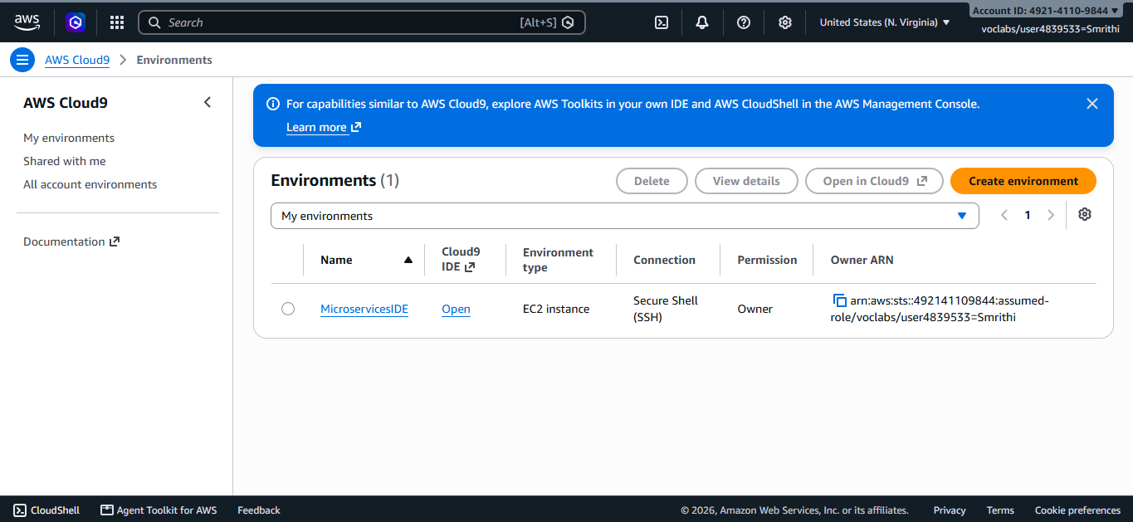

Figure 2: Amazon ECR – Customer and Employee Repositories
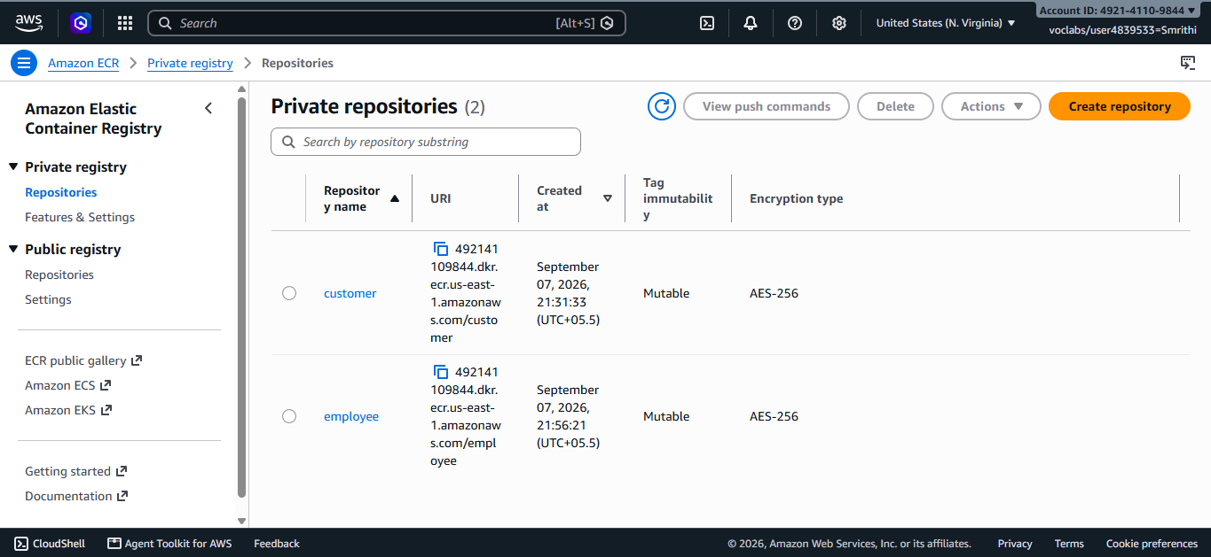

Figure 3: Amazon ECS – Microservices Cluster
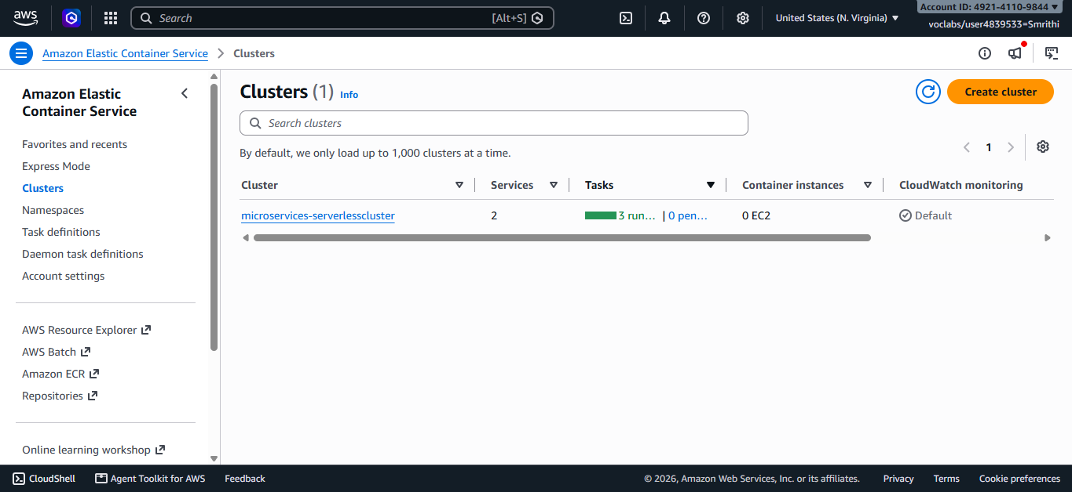

Figure 4: ECS Target Groups – Customer and Employee Services
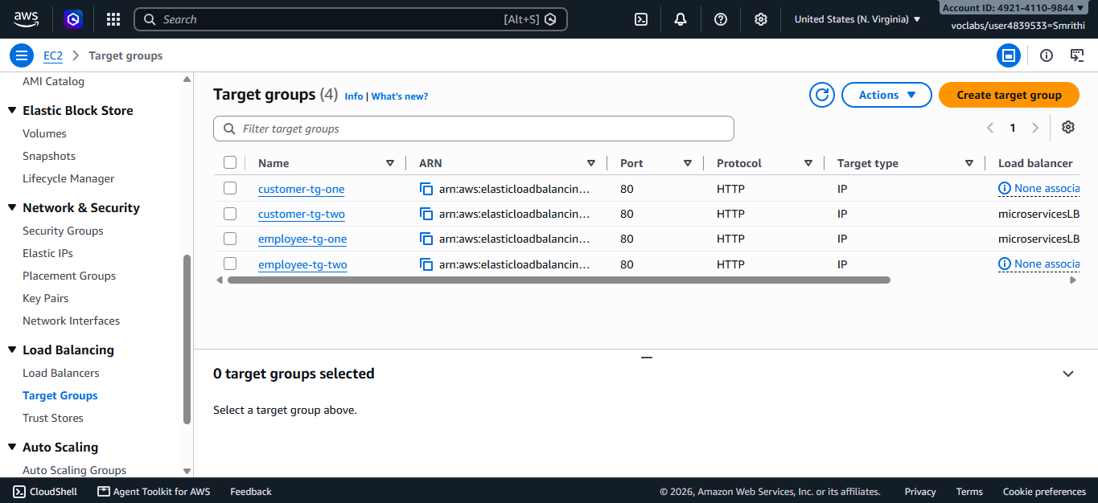

Figure 5: Application Load Balancer – microservicesLB
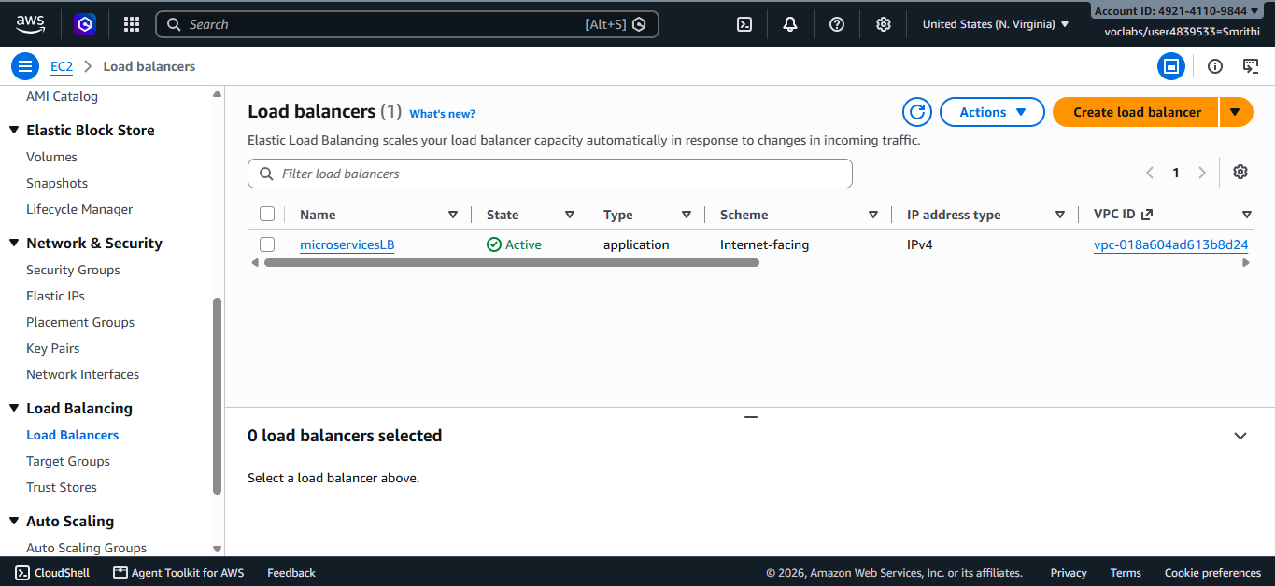

Figure 6: AWS Security Groups Configuration
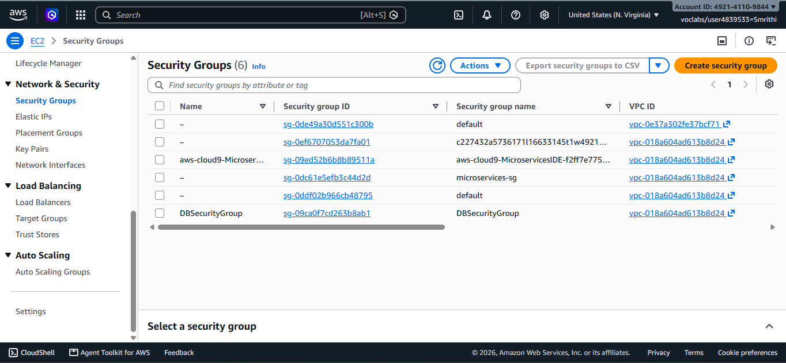

Figure 7: AWS CloudFormation – Successfully Created Stacks
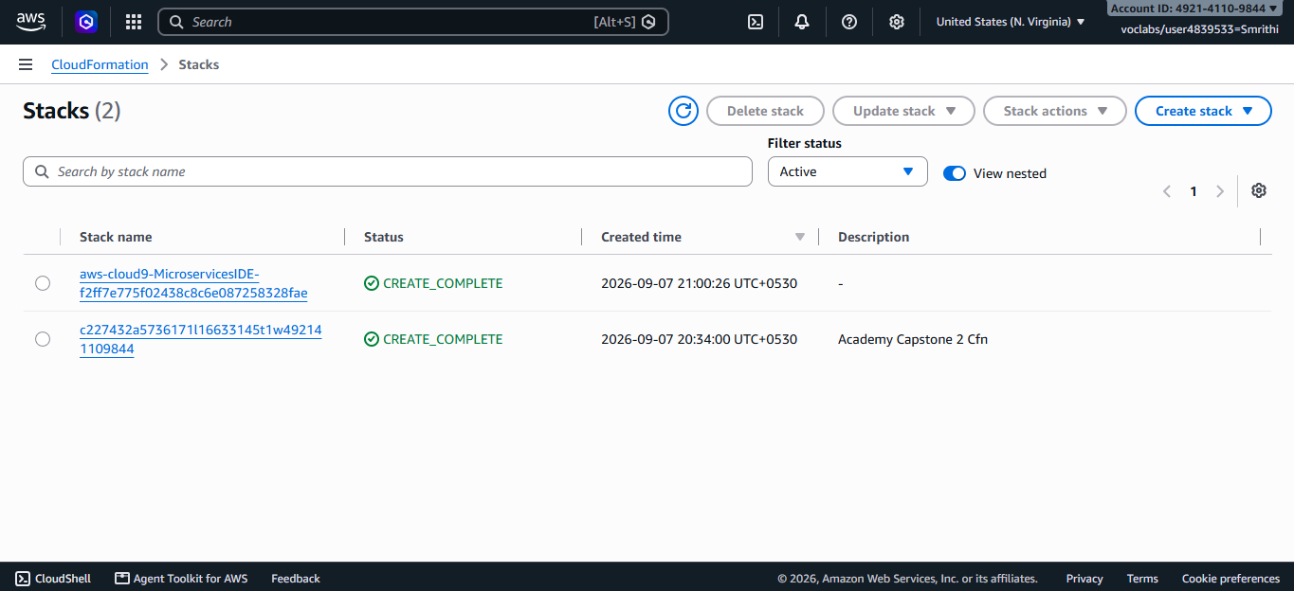

Figure 8: AWS CodeCommit – Deployment and Microservices Repositories
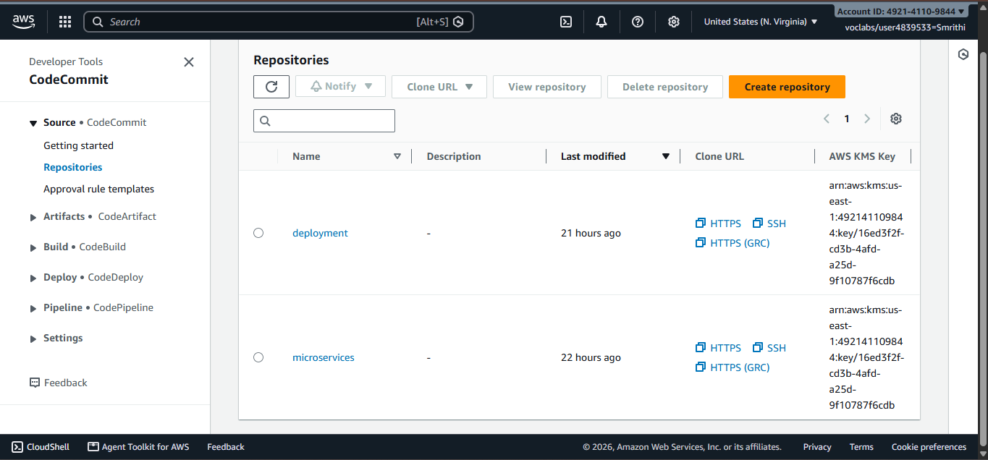

Figure 9: AWS CodePipeline – Successful Microservices Pipelines
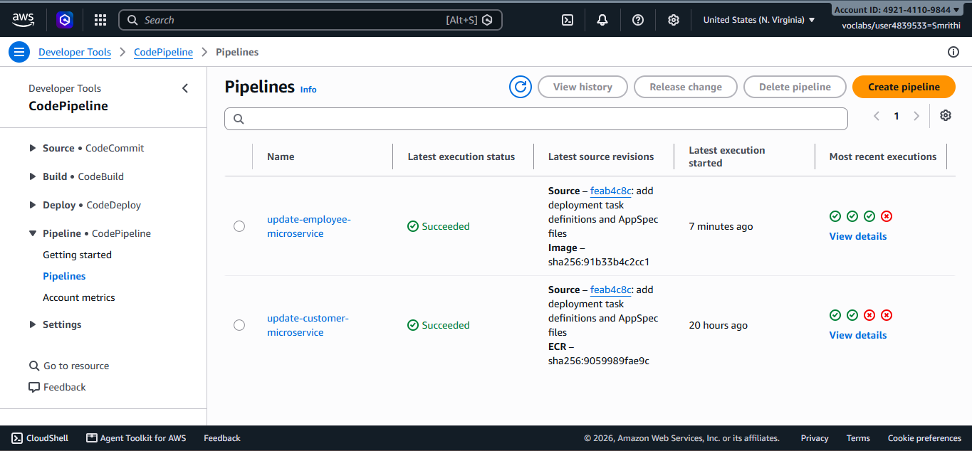

Figure 10: AWS CodeDeploy – Successful Deployment and Traffic Shift
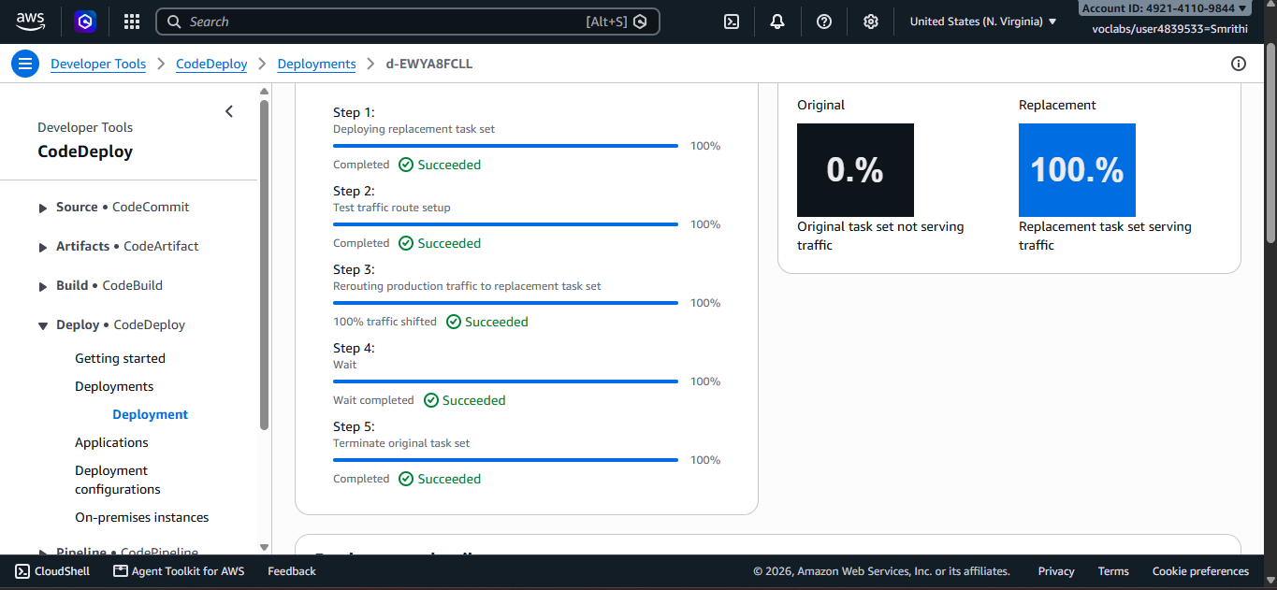

Figure 11: Deployed Coffee Suppliers Application
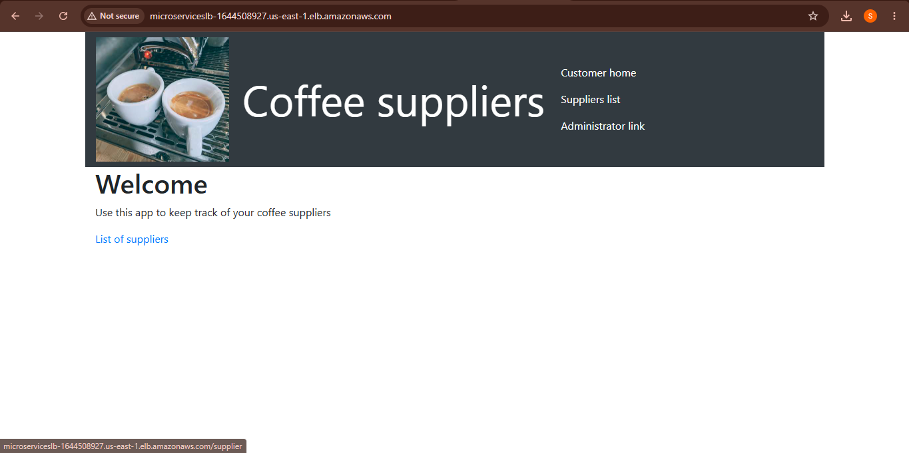

Figure 12: Cloud9 Terminal – Docker Image Build and Deployment
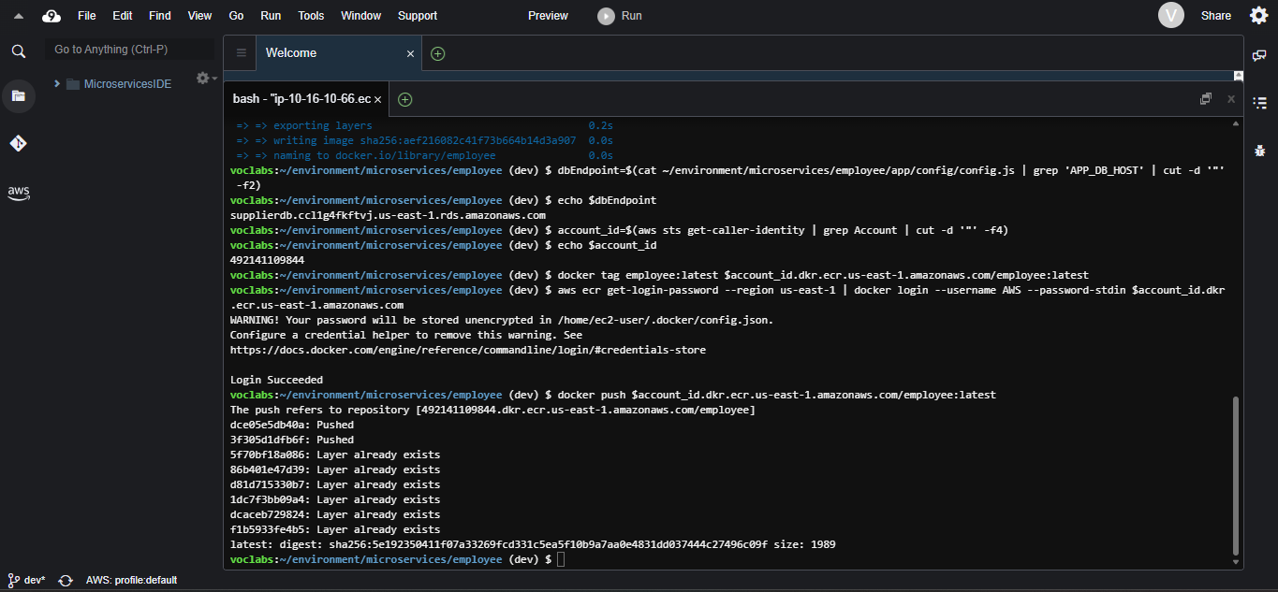

Figure 13: Manage Coffee Suppliers – Supplier List
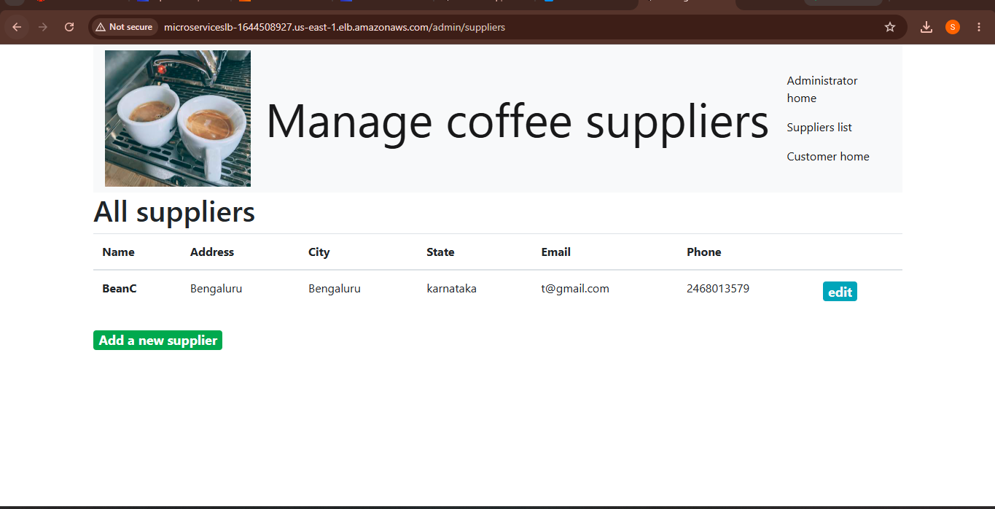

Figure 14: Cloud9 Terminal – ECS Task Definition Configuration
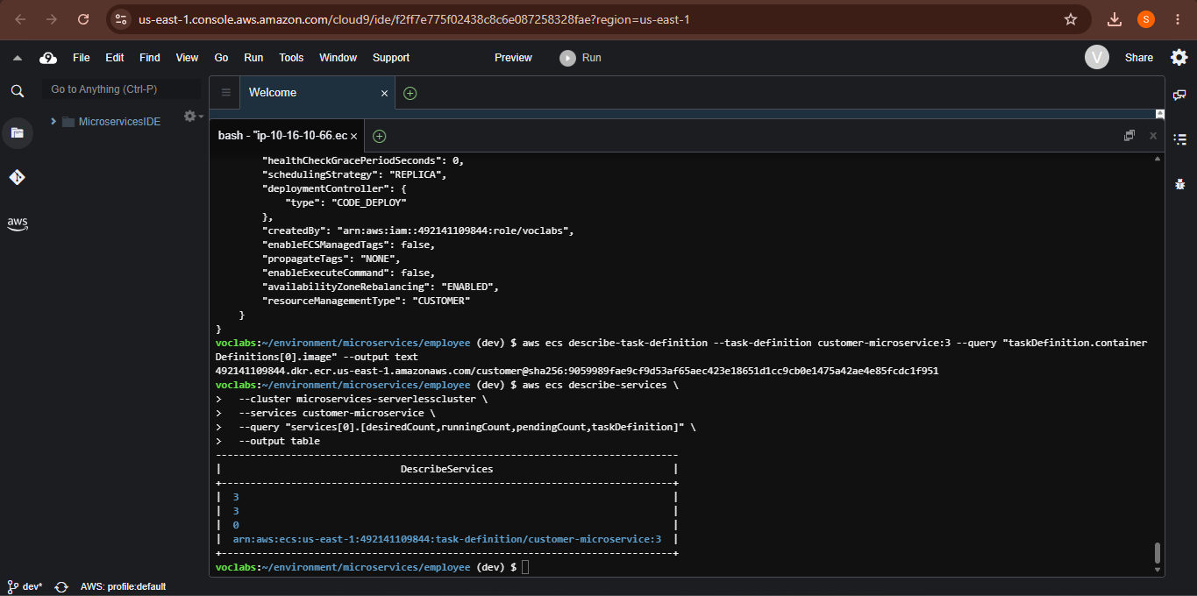

Figure 15: Amazon ECS – Running Microservice Tasks
